CHAPTER 3: Cells
Worksheet 3.5

Leafy exchanges
Student: Class:
Transpiration
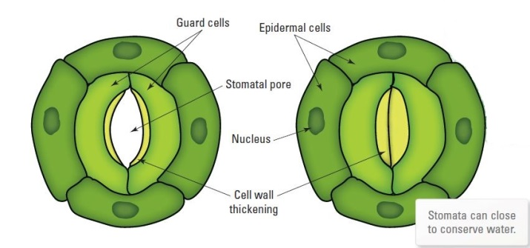
1. Consider the following two diagrams of the surface of a green leaf.
(a) Two stomates are shown. Explain why the stomatal pore at the left is open more widely than the one on the right.

(b) Define the term ‘transpiration’ in your own words.

(c) A student performed an experiment to measure the rate of transpiration using a bean seedling. She used the apparatus shown below.
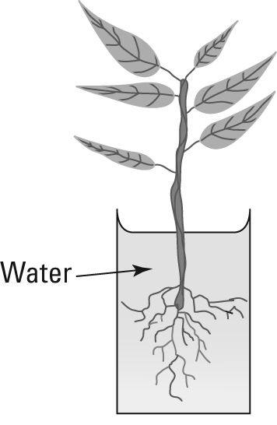 | (i) The student decided to place a thin layer of olive oil on the water surface before the experiment began. Explain why she did this.  (ii) Explain how the student will measure the rate of transpiration.
Density of stomates
2. A student wanted to find out if there are more stomates on the top or the bottom surface of a leaf. She painted the bottom surface of a small section of a leaf with nail polish. When the nail polish was dry she peeled it off and observed it under the microscope. She could see imprints of the stomates in the layer of nail polish.
(a) Explain what the student will need to do next. (Remember that she wants to find out if there are more stomates on the top or bottom of the leaf.).

(b) The student decides that instead of simply counting the stomates she should measure the density of stomates, i.e. how many stomates there are per cm² of leaf. Explain why this is necessary.

(c) The student finds that there is a much greater density of stomates on the bottom surface of the leaf. Suggest an explanation for this.

